The Cult-like Following of Playboi Carti

The artist behind many Billboard Hot 100 “works of art”, such as his many classics “Magnolia”(2017), “Wokeuplikethis\*”, “Shoota”(2018), and many more. “Magnolia” was truly his first breakout single that revealed to the public eye who this Playboi Carti person was. His hit single mentioned a popular dance move called the Milly Rock. Playboi Carti says, “In New York I Milly Rock,” referring to this dance move. A month later, popular Youtube influencer Roy Purdy uploaded a video to his Youtube channel doing the Milly Rock in New York to Playboi Carti’s “Magnolia” song. This video blew up with millions of views and people started sharing the song globally. Playboi Carti was now known in the “public eye.” This one song prospered his professional career, but years before there were other various hit singles that caused a rush of fans like the “Magnolia Effect.” One said hit single that privately exploded his career was “Broke Boi.”

“Broke Boi” is debatably one of Playboi Carti’s “best songs” due to his elaborate rhyming schemes and the hardcore instrumental behind his godly vocals. He sings, “Audi, Bimmer, Benz with the roof up. Still on this goop punch, three gram, boof blunt.” This one line that you may think is very simple, in fact it is not. This lyric shows his ability to rap effortless but cleanly. Shortly after Playboi Carti released “Broke Boi,” another song with him on it was dropped. It was dropped on Soundcloud along with “Broke Boi.” This song was titled “Fetti” and Playboi Carti was featured on this record along with Da$h and Maxo Kream. This song was also a hit online scoring millions of listens.

A year later, it’s 2017 and Playboi Carti dropped his afamed *Playboi Carti* (Self-Titled) mixtape with features from Lil Uzi Vert to A$AP Rocky. Shortly after his release of this project, fans still wanted more music(you will see this recurring in the future). Playboi Carti’s die hard fan base was wanting even more music. 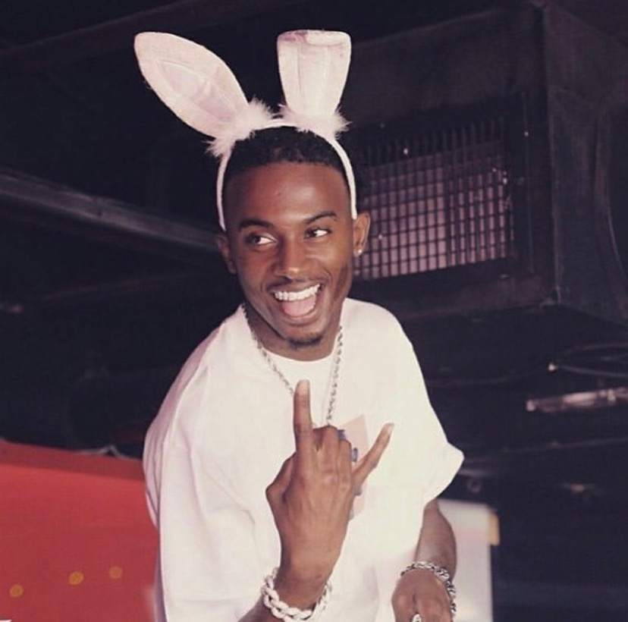

He frequently would share snippets of unreleased music on his various social media outlets. Constantly posting snippets of new music, fans were going crazy hearing these. Some fans even took it really far by hacking into the recording studios’ computers to get these unreleased files. After the hackers had this file, they didn’t just want to give out the song to the public, the hacker wanted money from the community. The hacker would post it on Music Mafia asking for a great sum of money in the low thousands range. Music Mafia is an illegal music sharing website where owners of these songs can host these songs online and ask for payments for it. One of Carti’s earliest leaks was called “Telly / We So Proud of Him.” This song had a high pitch beat with almost a piano sound effect going on. The song definitely made the die-hard fans happy. This was only the start for Playboi Carti leaks.

Fast forward to 2018, several leaks have dropped since then, and Playboi Carti fans think a new official album titled *Die Lit* will be released soon. Before Playboi Carti was even able to drop *Die Lit*, fans leaked new music. One song was “Let ‘Em In” and it sure was a hit. It showed that Carti was producing more music and some new music is to come very soon. Nine days later, Playboi Carti released *Die Lit* which shook the world by large. It included so many features from the likes of Travis Scott, Skepta, Chief Keef, etc. Even after his album release, fans still wanted more and more music. Fans began to leak more and more music in the near future.

Many Playboi Carti fans only really like the leaked songs. These songs were sometimes unfinished and sometimes even having only one verse completed. More and more hackers were making money off of these leaks. After Music Mafia got shut down in late 2018, fans posted music on leakth.is(Leak This). This website is a music leaking forum. These so called “group buys” would sometimes cost thousands of dollars just for a song or two.

Now in July-August of 2019, there has been at least nine Playboi Carti tracks leaked in a matter of a month. Things have definitely changed, for the better or for the worse. Playboi Carti has posted about how his songs have leaked and mentioned his leaked songs in interviews. Playboi Carti fans are really hungry for more music, always.